

**YOGA CENTER**

**Software Design Document**

– HCM, May 2023 –

**Table of Contents**

I. Overview 3

1. Code Packages/Namespaces 3

2. Database Schema 3

II. Code Designs 4

1. <Feature/Function Name1> 4

a. Class Diagram 4

b. Class Specifications 5

c. Sequence Diagram(s) 5

d. Database queries 6

III. Database Tables 6

1. Account 6

2. Role 6

3. Schedule 7

4. Courses 7

5. Booking 7

6. Classes 7

7. Semester 8

8. Payment 8

9. PaymentMethod 8

10. Premium 8

# I. Overview

## 1. Code Packages/Namespaces

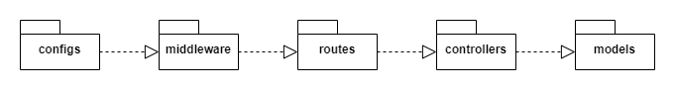

***Package descriptions & package class naming conventions***

|  |  |  |
| --- | --- | --- |
| **No** | **Package** | **Description** |
| 01 | configs | * The directory contains the application's configuration files. * lowercase (ex: config.js) |
| 02 | middleware | * Directory containing middleware files, used to perform processing tasks before the request reaches the destination. * camelCase (ex: userMiddleware.js) |
| 03 | routes | * The directory contains the route files to handle requests from the client and call the functions in the corresponding controller. * snake-case (user-routes.js) |
| 04 | controllers | * Directory containing file controllers to control application logic. * camelCase (ex: userController.js) |
| 05 | models | * Directory containing model files that define the database structure and methods for interacting with the database. * camelCase (ex: userModel.js) |

## 2. Database Schema

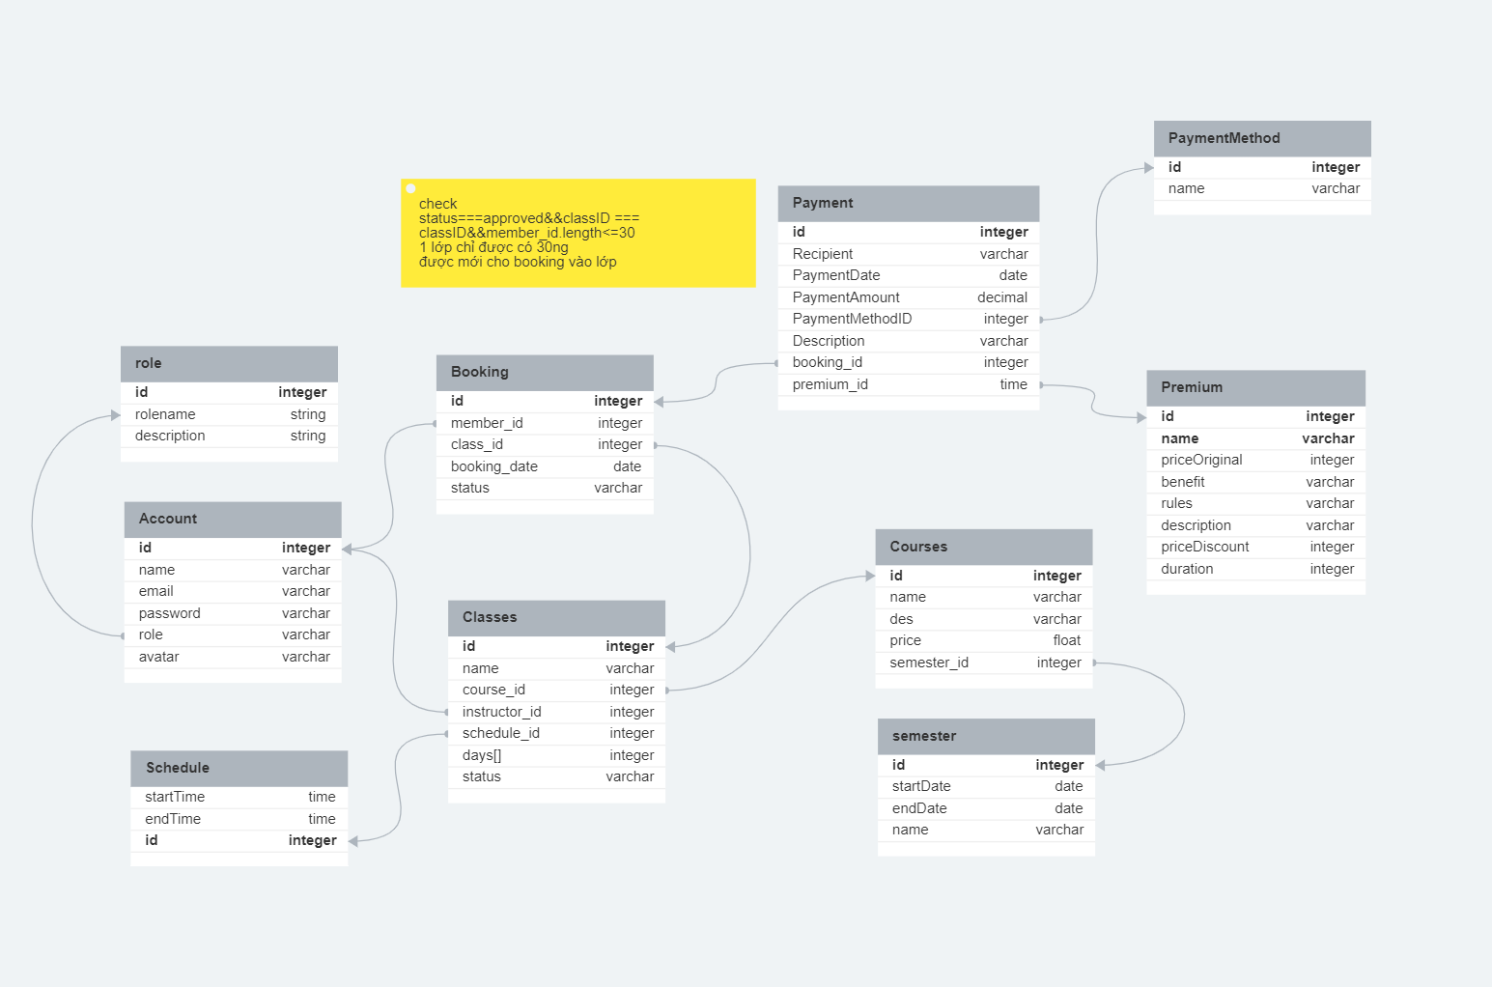

***Table descriptions & package class naming conventions are as below***

|  |  |  |
| --- | --- | --- |
| **No** | **Table** | **Description** |
|  | Account | * Contains information of all accounts logged into the system. * Primary key: account_id * Foreign key: role_id |
|  | Role | * Contain information of all role in the system. * Primary key: id |
|  | Booking | * Contains all information of customer booking * Primary key: booking_id * Foreign keys: account_id, class_id |
|  | Classes | * Contains information of all classes in charge of the instructor * Primary key: class_id * Foreign keys: courses_id schedule_id, account_id |
|  | Schedule | * Contains information of customer, staff schedule * Primary key: id |
|  | Courses | * Contains all information courses available * Primary key: courses_id * Foreign keys: semester_id |
|  | Semester | * Contains information of course in each semester * Primary key: semester_id |
|  | Payment | * Contains information of payment in the system. * Primary key: id * Foreign keys: bookig_id, method_id, premium_id |
|  | PaymentMethod | * Contains information of method payment in the system. * Primary key: id |
|  | Premium | * Contains information of premium package in the system. * Prima |

# II. Code Designs

# III. Database Tables

## 1. Account

|  |  |  |  |  |  |  |  |
| --- | --- | --- | --- | --- | --- | --- | --- |
| **#** | **Field name** | **Type** | **Size** | **Unique** | **Not Null** | **PK/FK** | **Notes** |
| 1. 1 | id | Integer | 4 | true | true | PK |  |
| 1. 2 | name | varchar | 0 to 65,535 |  |  |  |  |
|  | Email | varchar | 0 to 65,535 |  |  |  |  |
|  | password | varchar | 0 to 65,535 |  |  |  |  |
|  | Role_id | varchar | 0 to 65,535 |  |  | FK | Foreign key: role_id of table Role |
|  | Avatar | varchar | 0 to 65,535 |  |  |  |  |

## 2. Role

|  |  |  |  |  |  |  |  |
| --- | --- | --- | --- | --- | --- | --- | --- |
| **#** | **Field name** | **Type** | **Size** | **Unique** | **Not Null** | **PK/FK** | **Notes** |
| 1. 1 | id | Integer | 4 | true | true | PK |  |
| 1. 2 | Rolename | String |  | true |  |  |  |
|  | Email | String |  |  |  |  |  |

## 3. Schedule

|  |  |  |  |  |  |  |  |
| --- | --- | --- | --- | --- | --- | --- | --- |
| **#** | **Field name** | **Type** | **Size** | **Unique** | **Not Null** | **PK/FK** | **Notes** |
| 1. 1 | id | Integer | 4 | true | true | PK |  |
| 1. 2 | startTime | Time | 3 to 5 |  |  |  |  |
|  | endTime | Time | 3 to 5 |  |  |  |  |

## 4. Courses

|  |  |  |  |  |  |  |  |
| --- | --- | --- | --- | --- | --- | --- | --- |
| **#** | **Field name** | **Type** | **Size** | **Unique** | **Not Null** | **PK/FK** | **Notes** |
| 1. 1 | id | Integer | 4 | true | true | PK |  |
| 1. 2 | name | Varchar | 3 to 5 |  |  |  |  |
|  | Des | Varchar | 3 to 5 |  |  |  |  |
|  | price | Float | Depends on the value of n |  |  |  |  |
|  | Semester_id | Integer | 4 |  |  | FK | Foreign key: semester_id of table Semester |

## 5. Booking

|  |  |  |  |  |  |  |  |
| --- | --- | --- | --- | --- | --- | --- | --- |
| **#** | **Field name** | **Type** | **Size** | **Unique** | **Not Null** | **PK/FK** | **Notes** |
| 1. 1 | id | Integer | 4 | true | true | PK |  |
| 1. 2 | Member_id | Integer | 4 |  |  | FK | Foreign key: member_id of table Account |
|  | Class_id | Integer | 4 |  |  | FK | Foreign key: class_id of table Classes |
|  | Booking_date | Date | 3 |  |  |  |  |
|  | Status | Varchar | 0 to 65,535 |  |  |  |  |

## 6. Classes

|  |  |  |  |  |  |  |  |
| --- | --- | --- | --- | --- | --- | --- | --- |
| **#** | **Field name** | **Type** | **Size** | **Unique** | **Not Null** | **PK/FK** | **Notes** |
| 1. 1 | id | Integer | 4 | true | true | PK |  |
| 1. 2 | Course_id | Integer | 4 |  |  | FK | Foreign key: member_id of table Courses |
|  | Instructor_id | Integer | 4 |  |  | FK | Foreign key: class_id of table Account |
|  | Schedule_id | Integer | 4 |  |  | FK | Foreign key: class_id of table Schedule |
|  | Days | Array of Integer | 4 |  |  |  |  |
|  | Status | Varchar | 0 to 65,535 |  |  |  |  |

## 7. Semester

|  |  |  |  |  |  |  |  |
| --- | --- | --- | --- | --- | --- | --- | --- |
| **#** | **Field name** | **Type** | **Size** | **Unique** | **Not Null** | **PK/FK** | **Notes** |
| 1. 1 | id | Integer | 4 | true | true | PK |  |
| 1. 2 | startDate | Date | 3 |  |  |  |  |
|  | endDate | Date | 3 |  |  |  |  |
|  | Name | Varchar | 0 to 65,535 |  |  |  |  |

## 8. Payment

|  |  |  |  |  |  |  |  |
| --- | --- | --- | --- | --- | --- | --- | --- |
| **#** | **Field name** | **Type** | **Size** | **Unique** | **Not Null** | **PK/FK** | **Notes** |
| 1. 1 | id | Integer | 4 | true | true | PK |  |
| 1. 2 | PaymentDate | Date | 3 |  |  |  |  |
|  | PaymentAmount | Date | 3 |  |  |  |  |
|  | Recipient | Varchar | 0 to 65,535 |  |  |  |  |
|  | Description | Varchar | 0 to 65,535 |  |  |  |  |
|  | PaymentMethodID | Integer | 4 |  |  | FK | Foreign Key: paymentmethod_id of table PaymentMethod |
|  | booking_id | Integer | 4 |  |  | FK | Foreign Key: booking_id of table Booking |
|  | premium_id | Integer | 4 |  |  | FK | Foreign Key: premium_id of table Premium |

## 9. PaymentMethod

|  |  |  |  |  |  |  |  |
| --- | --- | --- | --- | --- | --- | --- | --- |
| **#** | **Field name** | **Type** | **Size** | **Unique** | **Not Null** | **PK/FK** | **Notes** |
| 1. 1 | id | Integer | 4 | true | true | PK |  |
| 1. 2 | Name | Varchar | 0 to 65,535 |  |  |  |  |

## 10. Premium

|  |  |  |  |  |  |  |  |
| --- | --- | --- | --- | --- | --- | --- | --- |
| **#** | **Field name** | **Type** | **Size** | **Unique** | **Not Null** | **PK/FK** | **Notes** |
| 1. 1 | id | Integer | 4 | true | true | PK |  |
| 1. 2 | name | Varchar | 0 to 65,535 |  |  |  |  |
|  | benefit | Varchar | 0 to 65,535 |  |  |  |  |
|  | rules | Varchar | 0 to 65,535 |  |  |  |  |
|  | description | Integer | 4 |  |  |  |  |
|  | priceOriginal | Integer | 4 |  |  |  |  |
|  | priceDiscount | Integer | 4 |  |  |  |  |
|  | duration | Integer | 4 |  |  |  |  |